Name: VALLI DEVI K
Batch: 11

- Create a Github repository with name ABC – 20092025
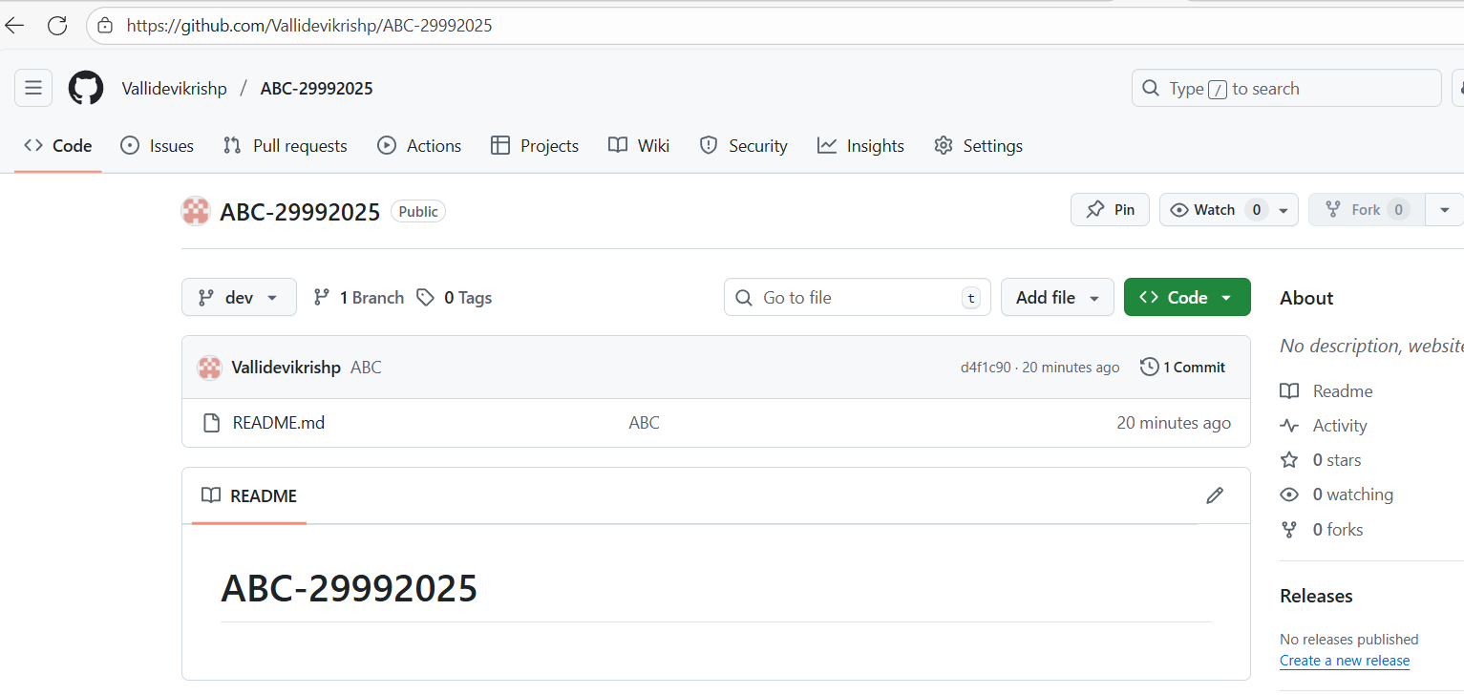
- Create a container registry using terraform.

Pre-requites:

• Azure CLI installed and authenticated (az login)
- Terraform installed (terraform -v)
- Active Azure subscription
- A working directory for your Terraform files
- 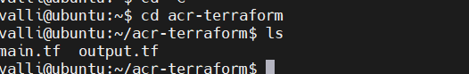
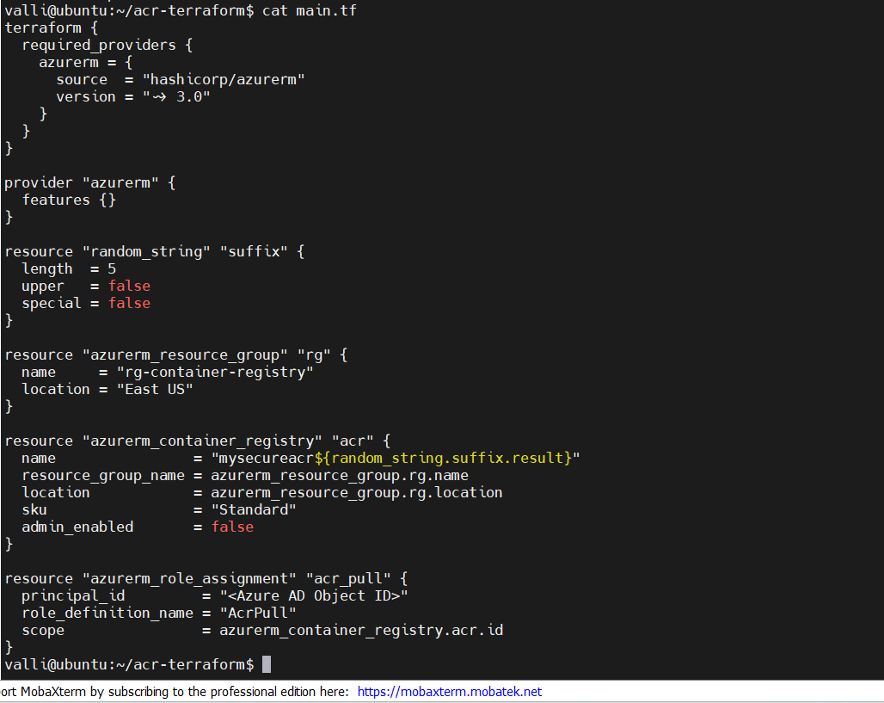
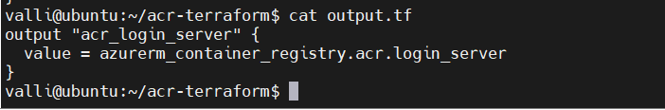
Step 1: Set Up Your Terraform Configuration
Create a new folder and initialize your Terraform project:
mkdir acr-terraform && cd acr-terraform
Create a file named main.tf and add the following:
terraform { required_providers { azurerm = { source = "hashicorp/azurerm" version = "~> 3.0" } } } provider "azurerm" { features {} }

Secure Access with Azure AD (Optional but Recommended)
If you're integrating with Azure AD for secure access control:
resource "azurerm_role_assignment" "acr_pull" { principal_id = "" role_definition_name = "AcrPull" scope = azurerm_container_registry.acr.id }
Replace with the service principal or user object ID.
Output Registry Details
Add this to outputs.tf:
output "acr_login_server" { value = azurerm_container_registry.acr.login_server }
Initialize and Apply
Run the following commands:
terraform init terraform plan terraform apply

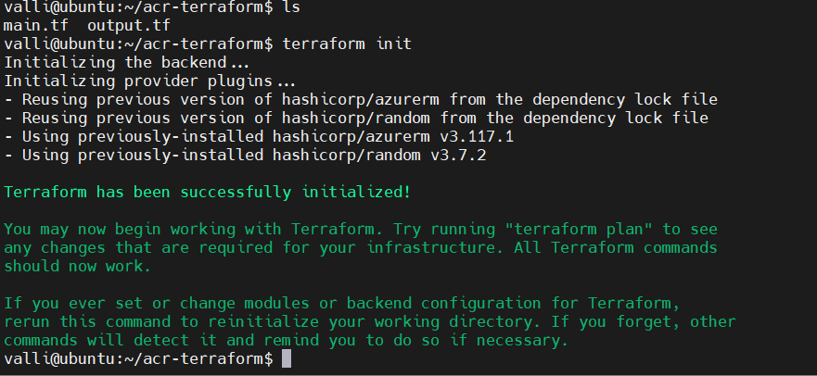
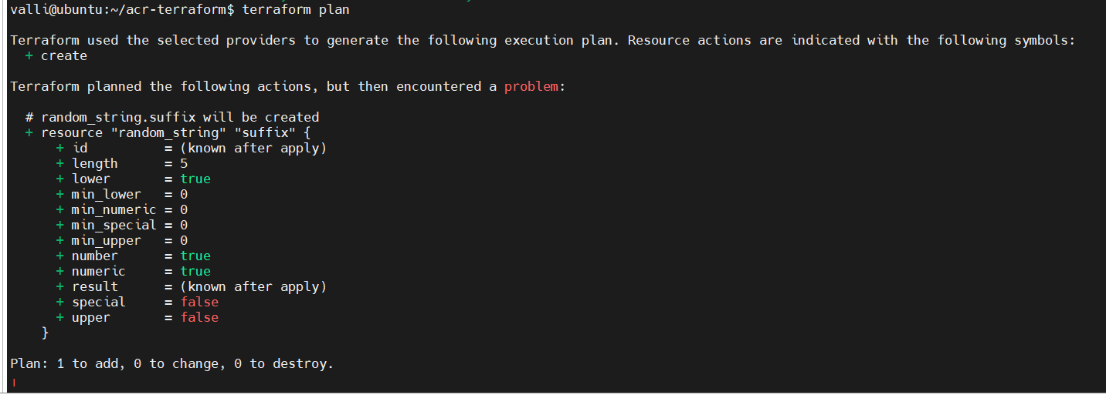
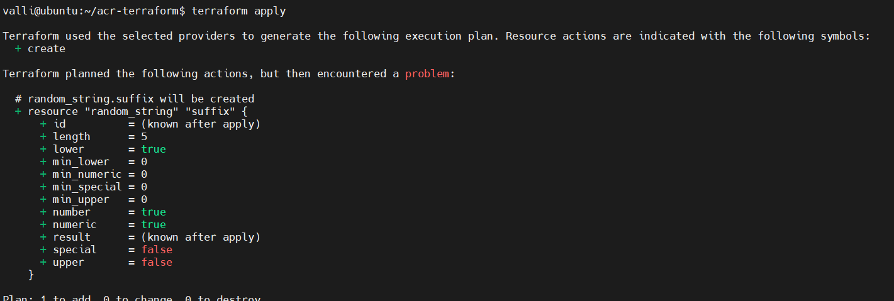
Confirm when prompted. Terraform will provision the resource group and ACR.
Step 6: Verify and Use
After deployment:
- Use az acr list to verify the registry
- Push images using Docker:
az acr login --name docker tag myimage /myimage:v1 docker push /myimage:v1
Optional Enhancements
- Enable geo-replication for multi-region deployments
- Integrate with Key Vault for secret management
- Add lifecycle rules for image retention

  - Create a docker image using build artifact and push to container registry

- create a docker image and verify running
Create a Simple App
Let’s use a basic Python app as an example. Create a folder and add these files:
app.py
from flask import Flask
app = Flask(__name__)

@app.route('/')
def hello():
return "Hello from Docker!"

if __name__ == '__main__':
app.run(host='0.0.0.0', port=5000)

requirements.txt
flask

Dockerfile

# Use official Python image
FROM python:3.9-slim

# Set working directory
WORKDIR /app

# Copy files
COPY requirements.txt .
RUN pip install -r requirements.txt

COPY app.py .

# Expose port
EXPOSE 5000

# Run the app
CMD ["python", "app.py"]

Build the image
docker build -t my-flask-app .

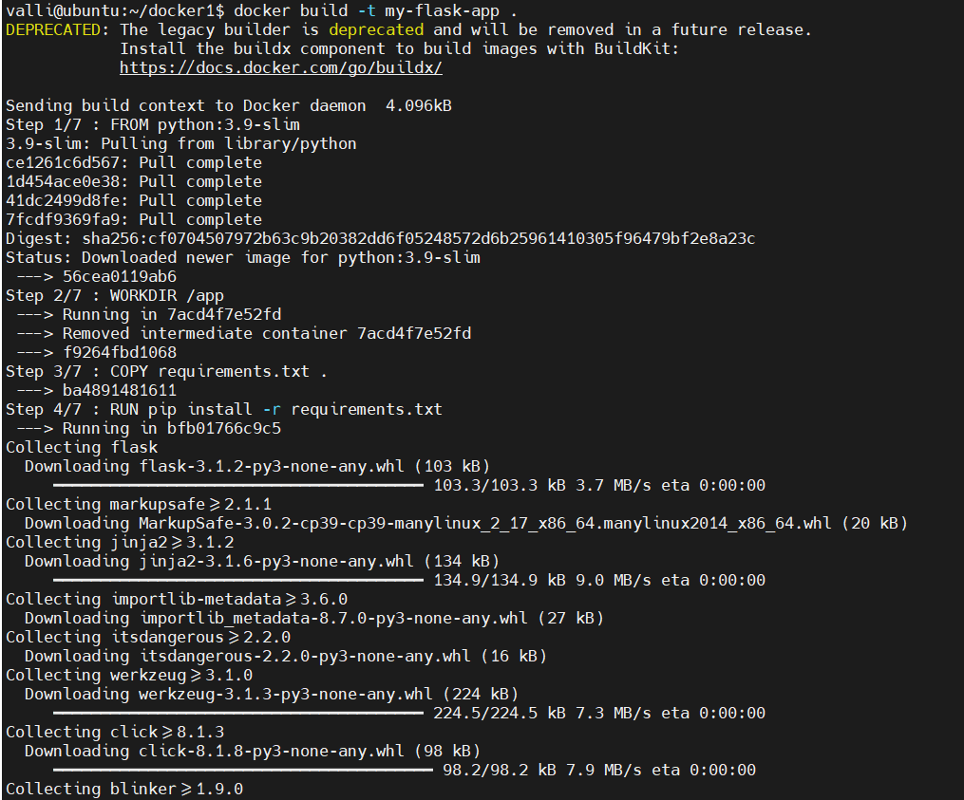
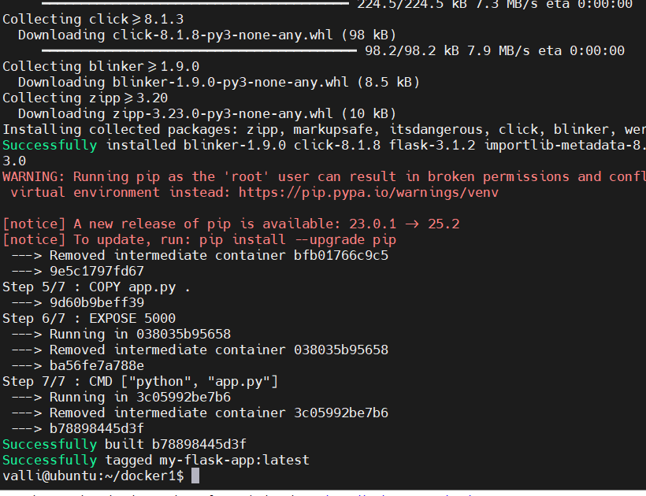
Run the container
docker run -d -p 5000:5000 --name flask-container my-flask-app

docker ps – verify the running

curl http://localhost:5000

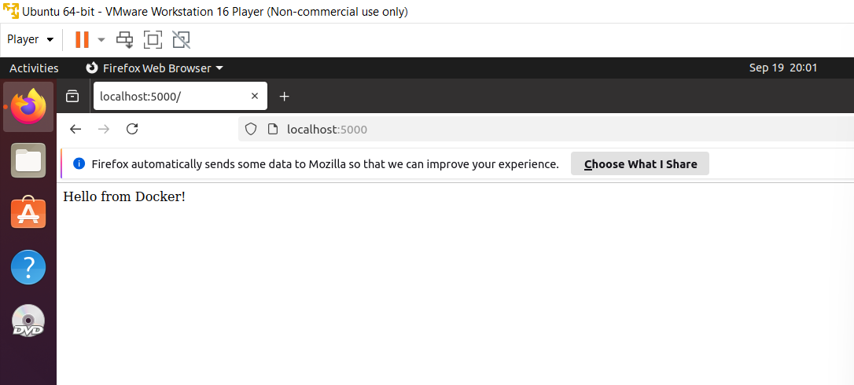

- Maven
Stage 1: Create and Build Maven Webapp
✅ Step 1.1: Generate the Project
Run this command to scaffold a webapp using Maven archetype:
mvn archetype:generate \
-DgroupId=com.valli.webapp \
-DartifactId=my-webapp \
-DarchetypeArtifactId=maven-archetype-webapp \
-DinteractiveMode=false

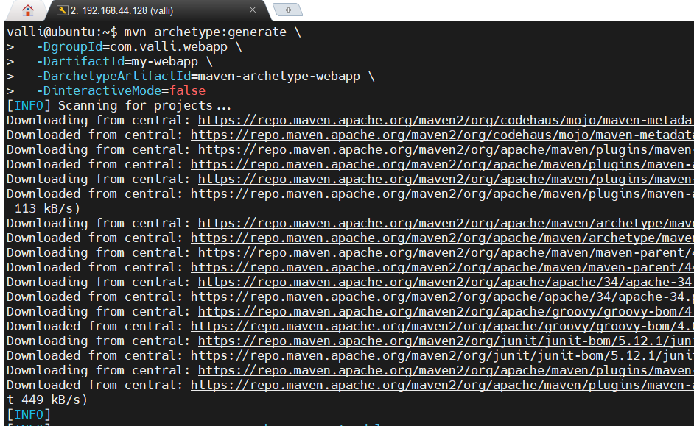
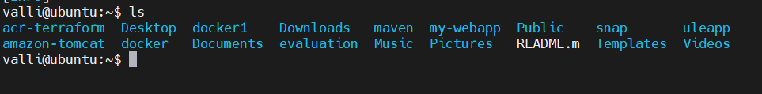

This creates a structure like:
my-webapp/
├── pom.xml
└── src/
└── main/
└── webapp/
├── index.jsp
└── WEB-INF/
└── web.xml

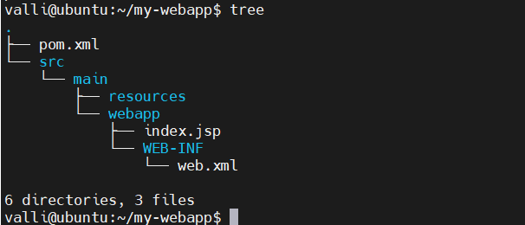

✅ Step 1.2: Update pom.xml
Ensure your pom.xml includes a plugin to build a WAR file:
<project xmlns="http://maven.apache.org/POM/4.0.0"
xmlns:xsi="http://www.w3.org/2001/XMLSchema-instance"
xsi:schemaLocation="http://maven.apache.org/POM/4.0.0
http://maven.apache.org/xsd/maven-4.0.0.xsd">
<modelVersion>4.0.0</modelVersion>

<groupId>com.valli.webapp</groupId>
<artifactId>my-webapp</artifactId>
<version>1.0</version>
<packaging>war</packaging>

<build>
<plugins>
<plugin>
<groupId>org.apache.maven.plugins</groupId>
<artifactId>maven-war-plugin</artifactId>
<version>3.3.2</version>
</plugin>
</plugins>
</build>
</project>

Step 1.3: Build the WAR Artifact
cd my-webapp
mvn clean package

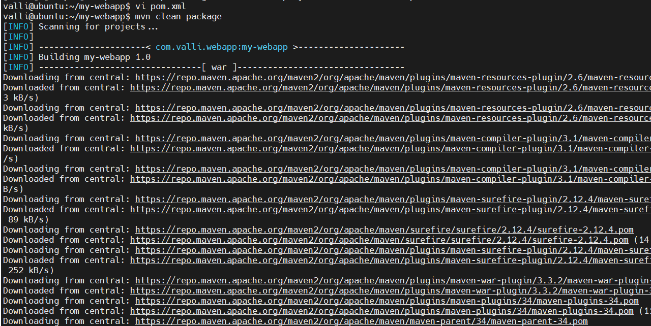
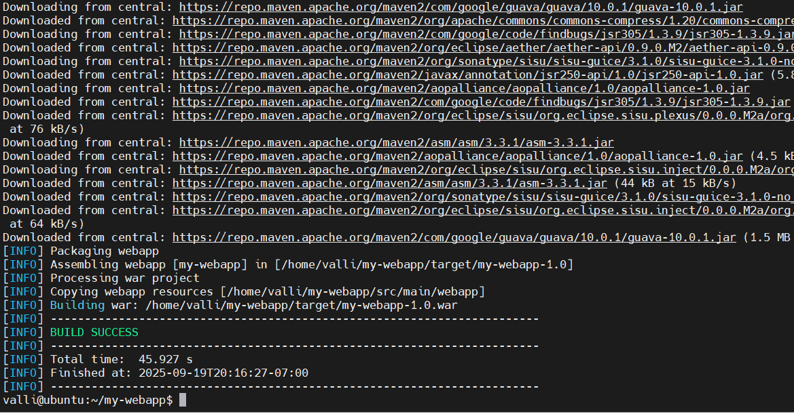
This generates target/my-webapp.war.
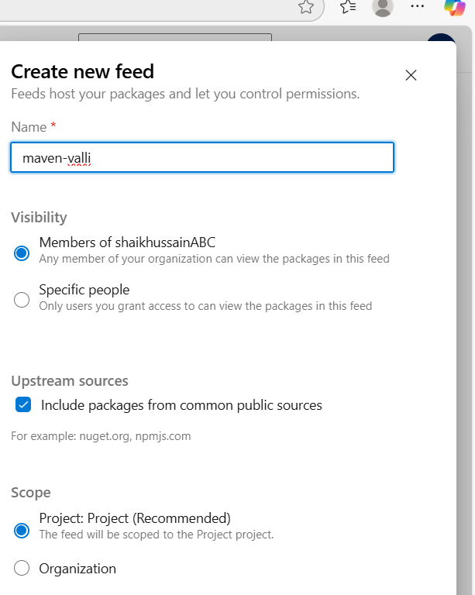
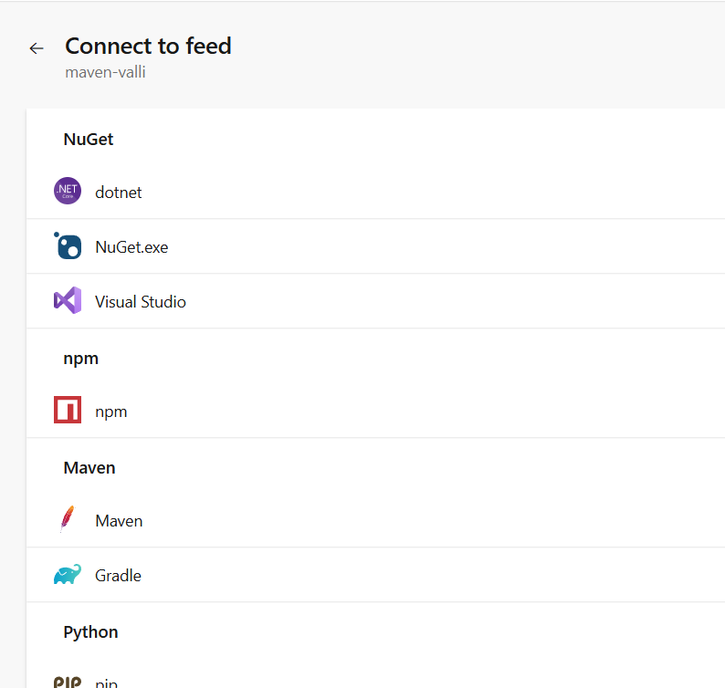

🐳 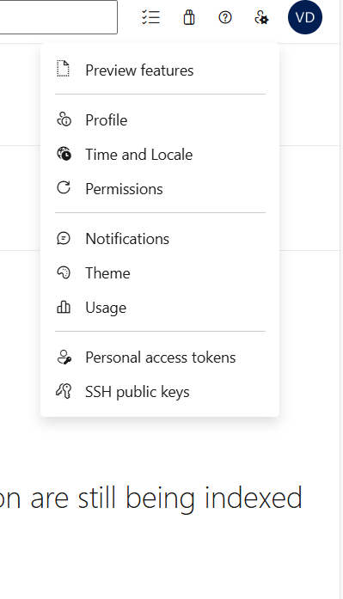

Stage 2: Dockerize and Push to 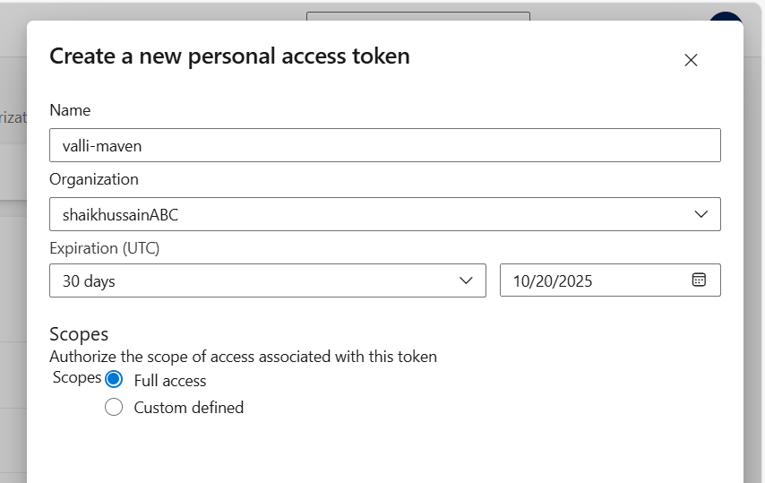

1XZ57x1j6vnTlxj2NJy06HZXSe8cLoh8qNqkW45E1iE2IaI7uzR7JQQJ99BIACAAAAAAAAAAAAASAZDO2nhj

n ~/.m2/settings.xml)

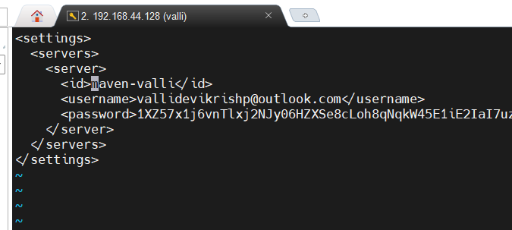

Registry
✅ Step 2.1: Create Dockerfile
In the root of your project, create a Dockerfile:
FROM tomcat:9.0-jdk11

# Remove default webapps
RUN rm -rf /usr/local/tomcat/webapps/*

# Copy WAR file
COPY target/my-webapp.war /usr/local/tomcat/webapps/ROOT.war

EXPOSE 8080

✅ Step 2.2: Build Docker Image
docker build -t my-webapp-image .

✅ Step 2.3: Run and Verify Locally
docker run -d -p 8080:8080 --name webapp-container my-webapp-image
curl http://localhost:8080

You should see the contents of index.jsp.

☁️ Step 2.4: Push to Azure Container Registry (ACR)
🔐 Authenticate with Azure
az login
az acr login --name <your-acr-name>

🏷️ Tag the Image
docker tag my-webapp-image <your-acr-name>.azurecr.io/my-webapp-image:v1


📤 Push to ACR
docker push <your-acr-name>.azurecr.io/my-webapp-image:v1

🧠 Bonus: Automate with CI/CD
You can now integrate this into an Azure DevOps pipeline:
- Use Maven@3 task to build
- Use Docker@2 task to build and push
- Inject secrets via Key Vault
- Add approval gates before pushing to ACR

Want help modularizing this into a reusable pipeline template or adding quality gates with SonarQube? I can help you build that out next.
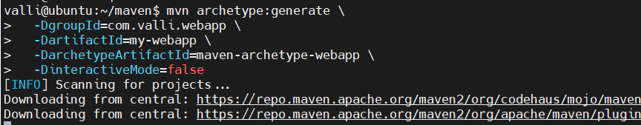

5.

- Configure Approval in Azure DevOps UI
- Approvals aren’t defined in YAML — they’re set in the portal:
- Go to Pipelines > Environments
- Select your environment (PreDeploy)
- Click Approvals and checks
- Add a Manual Approval
- Choose who must approve (user or group)
- Once this is set, Azure DevOps will pause the pipeline at that stage until approval is granted.
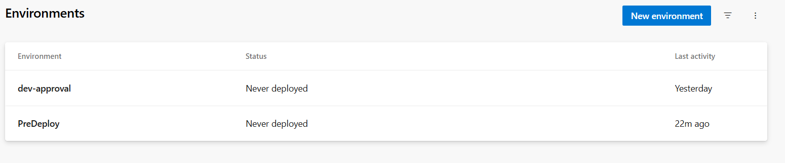
- Create New pipeline
- Configure pipeline with required details
- This structure ensures:
- The Approval stage waits for the Build to succeed
- The PreDeploy environment triggers the manual approval
- Only after approval, the Deploy stage runs

trigger: none
pool:
name: pool1
stages:
- stage: Build
jobs:
- job: BuildJob
steps:
- script: mvn clean package -X
workingDirectory: $(Build.SourcesDirectory)/your-subfolder
- stage: Approval
dependsOn: Build
condition: succeeded()
jobs:
- deployment: WaitForApproval
environment: 'PreDeploy'
strategy:
runOnce:
deploy:
steps:
- script: echo "Waiting for approval..."
- stage: Deploy
dependsOn: Approval
condition: succeeded()
jobs:
- job: DeployJob
steps:
- script: mvn deploy

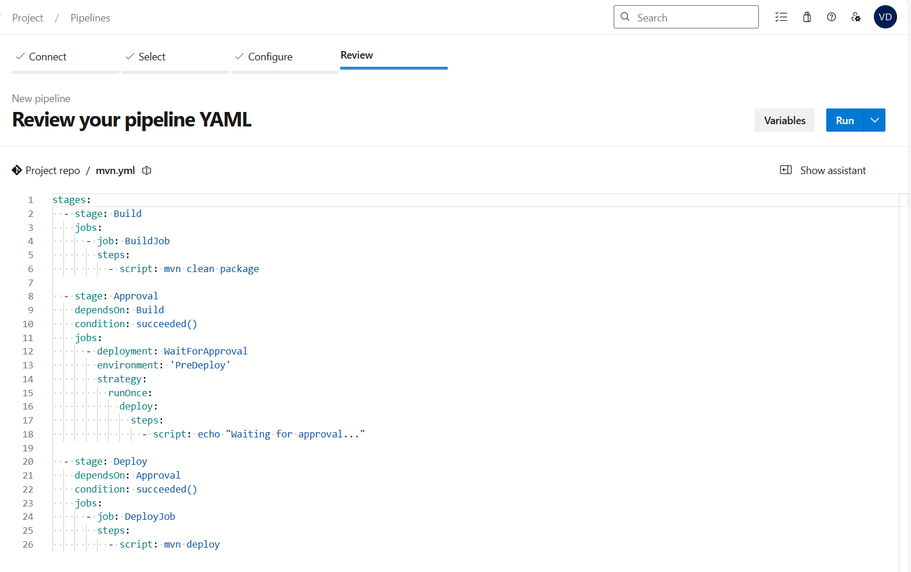

- Check the pipeline status
- Artifact has been published
- Post-job approval is done
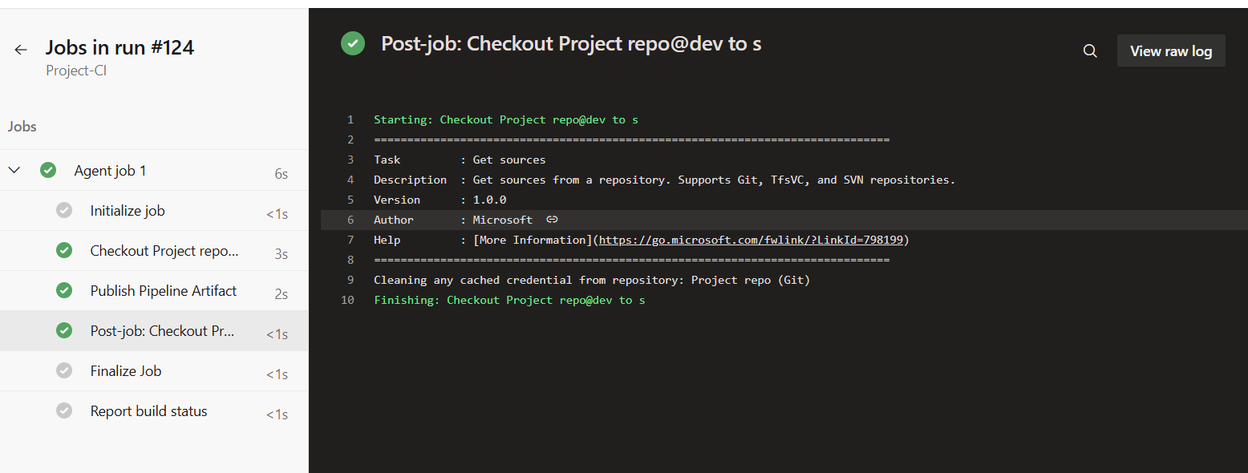
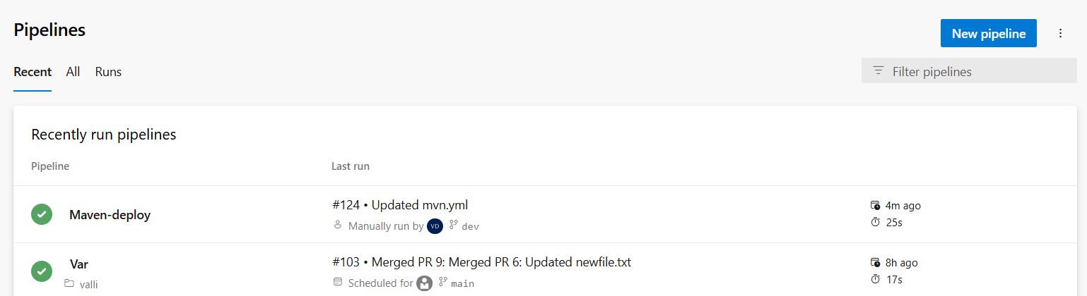

- How to use pat tokens in pipeline and secret in variable group in azure devops
Generate and Store Your PAT Token
- Create a PAT:
- Go to your Azure DevOps profile → User Settings → Personal Access Tokens
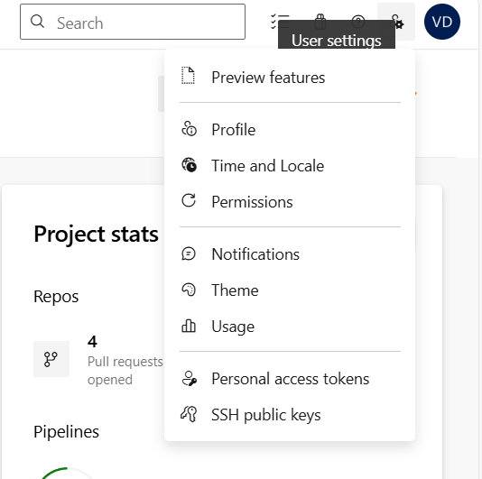
- Click + New Token
- Choose scopes (e.g., Code: Read & Write for Git access)
- Set a short expiration (e.g., 30–90 days)
- Copy the token immediately—it's shown only once 8K6eN33B0LTGLHdtPur7HV05o5BXghq460YNZJxCFIsPMQ8EDQwdJQQJ99BIACAAAAAAAAAAAAASAZDO37hs
- Store PAT as a Secret Variable:
- Go to Pipelines → Library → + Variable Group
- Create a variable like gitPatToken
- Mark it as secret
